Experiment 29:
Aim:
29.Write a Python programming to display a bar chart of the popularity of programming Languages. Use different color for each bar.
Python code:
import matplotlib.pyplot as plt

# Data
languages = ['Java', 'Python', 'PHP', 'JavaScript', 'C#', 'C++']
popularity = [22.2, 17.6, 8.8, 8, 7.7, 6.7]
colors = ['red', 'green', 'blue', 'orange', 'purple', 'brown']

# Create bar chart with different color for each bar
plt.bar(languages, popularity, color=colors)

# Add labels and title
plt.xlabel('Programming Language')
plt.ylabel('Popularity (%)')
plt.title('Popularity of Programming Languages')

plt.show()
Output:
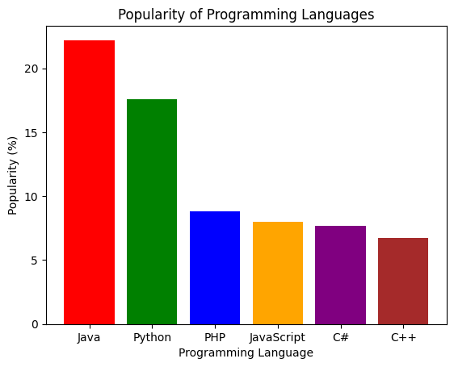
Experiment 30:
Aim:
30.Write a Python program to create bar plot of scores by group and gender. Use multiple X values on the same chart for men and women.
Python code:
import matplotlib.pyplot as plt
import numpy as np

# Data
groups = ['G1', 'G2', 'G3', 'G4', 'G5']
men_scores = [22, 30, 35, 35, 26]
women_scores = [25, 32, 30, 35, 29]

x = np.arange(len(groups)) # label locations
width = 0.35 # width of the bars

fig, ax = plt.subplots()
bar1 = ax.bar(x - width/2, men_scores, width, label='Men', color='steelblue')
bar2 = ax.bar(x + width/2, women_scores, width, label='Women', color='lightcoral')

# Add labels, title and legend
ax.set_xlabel('Group')
ax.set_ylabel('Scores')
ax.set_title('Scores by Group and Gender')
ax.set_xticks(x)
ax.set_xticklabels(groups)
ax.legend()

plt.show()
Output:
